# Replace List Elements - Python Exercise

Below is the image provided along with the recreated question, terminal output, and answer:

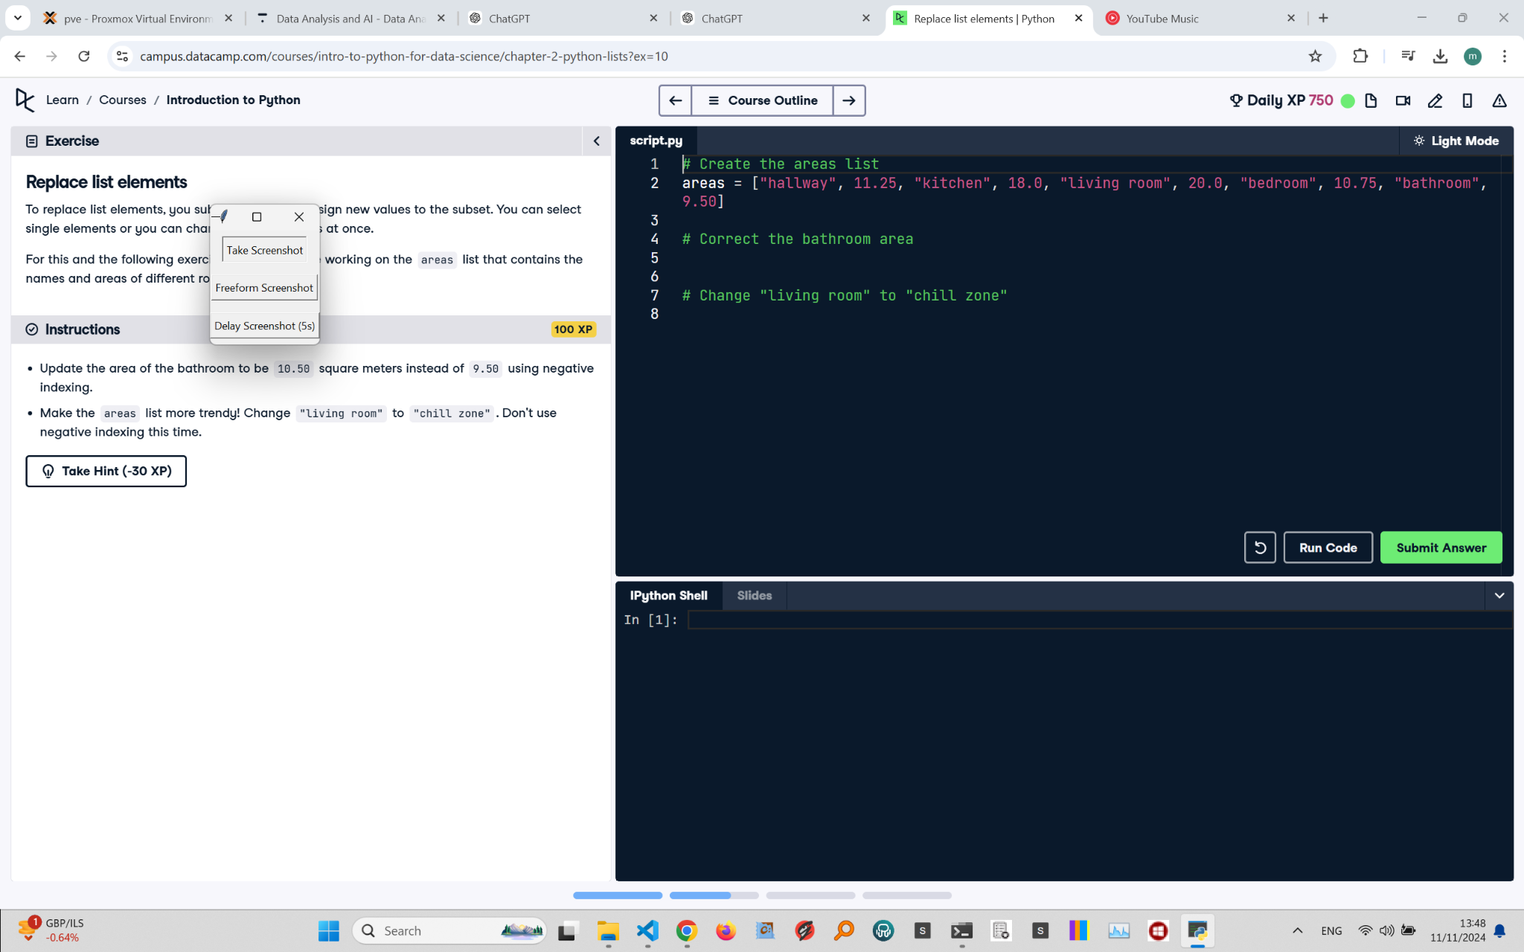

## Recreated Question and Terminal

Replace List Elements  
To replace list elements, you subset the list and assign new values to the subset. You can select single elements or you can change entire sublists at once.

Instructions:  
- Update the area of the bathroom to be 10.50 square meters instead of 9.50 using negative indexing.  
- Make the areas list more trendy! Change "living room" to "chill zone". Don't use negative indexing this time.

## Answer

# Create the areas list  
areas = ["hallway", 11.25, "kitchen", 18.0, "living room", 20.0, "bedroom", 10.75, "bathroom", 9.50]  
  
# Correct the bathroom area using negative indexing  
areas[-1] = 10.50  
  
# Change "living room" to "chill zone"  
areas[4] = "chill zone"  
  
# Print the updated areas list  
print(areas)

## Explanation of the Answer

The code updates specific elements in the areas list. areas[-1] uses negative indexing to change 9.50 to 10.50. areas[4] modifies the string "living room" to "chill zone" without using negative indexing. The updated areas list is then printed.